Yelp AWS Assignment

1. YR_S-vzXBXHLkUoDbidjPg reviews mainly art galleries, medical/dental facilities, and coffee shops with a few others thrown in.
2. The Cowfish Sushi Burger Bar. Tequileria. Pinky's Westside Grill. Bonus: Chili Man / Round Point Mortgage Servicing
3. 1562 no longer open. Avg of Not Open: 3.49. Avg of Open: 3.70. Some difference, but not a ton
4. Average Stars per year was remarkably steady from 2006-2018 with the high at 3.75 and the low at 3.61. Peak use of ‘Funny’ and ‘Cool’ responses was in 2010 where ‘Cool’ had an average of 1.12 cool tags per review, and ‘Funny’ had an average of 1.09 tags per review.
5. Af0-vJrHIx2agB5Zzv8idA Thuy T; Two Star reviews had the most words at 137.4 on average, but One Star reviews also had a lot at 135.5. 5 Star reviews had the least number of words at 86.7. Assuming 25 or more reviews: fw6jdJy2pBud2Ux32vIVYQ ART Dentistry but if you don’t require that minimum: hFNyMFD0_6TCuDEs9Oc1tA Oasis at Regal Oak
6. SlgpAnj2gQd44EM_Uq6DkQ Jeff mentions ‘beer’ most frequently in his reviews, therefore I will go with him. (I also like beer.)
7. Power Map:

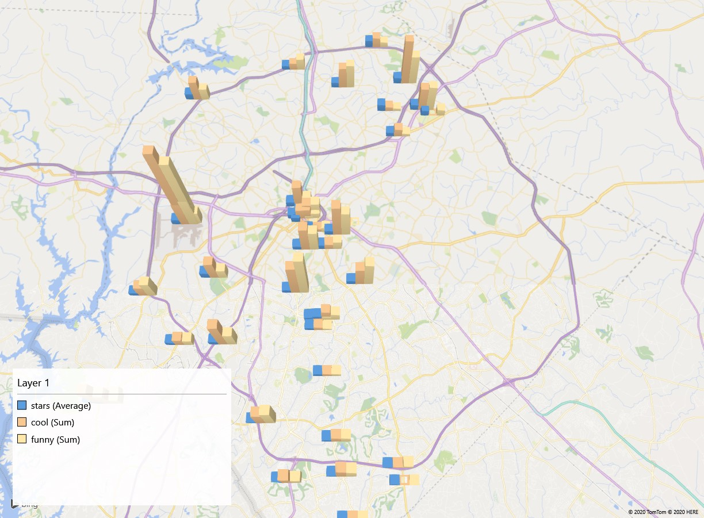

Difficult Bonus: No clue